# 

*is Dirty Business*

*Read on if you dare…*

*Make* ***PLANS*** *to keep our lake healthy!!!!*

***P****hosphorus Free*

***L****eaves/Grass/Lights Out*

***A****nimal Waste Out*

***N****ative Plants In*

***S****eptic Systems Maintained*

*Lake Papkeechie est. 1914*

*Everyone can do something to help keep our lake around by making* ***PLANS*** *now.*

*Lake Papakeechie Sustainability Initiative*

***Keeping Our***

***Lake Healthy***

**Let’s Close With Tranquility and Beauty.**

We can actually create more beauty and tranquility in our own back yards by making rain gardens that naturally filter water. Using native plants adapted for your area in your rain garden will allow you to use less fertilizer.  Rain barrels can provide a conservative way to water. Landscaping with rocks and dirt helps water drain and filter run off.

**Are You Trespassing Lightly?**

Be kind to your neighbors and the wildlife. Light trespassing interferes with enjoyment of the stars at night and it can disrupt the mating, food finding, sleeping, and migration of fish and wildlife. Night lighting has also been found to lead to excessive algae. Studies show there is no correlation between night lighting and crime. Motion sensors are much more effective because they indicate the presence of activity. If you must use outside lighting, use motion detectors or shielding to direct the light only to where it needs to be.

# Your Dog is Not a Goose!

While we can't follow the geese around with a baggie, we can keep track of our pets and reduce the runoff of phosphorus and E. coli bacteria by cleaning up after them.

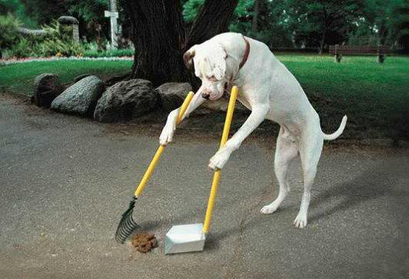

# Don’t Be a Muckmaker!

Lakes have a finite life span. Raking leaves and grass clippings into the lake speeds up the aging process. They contribute to the fill-in process, create muck for you and your neighbor and rob our lake of vital oxygen. They also add nutrients that can promote other problems such as an increase in algae.

# Want More Algae and Weeds?

Most fertilizers contain phosphorous. Excessive phosphorous is the primary cause of degraded lake water quality. It promotes plant growth in lakes, just as it does in home gardens. However, in lakes the crop is algae, and sometimes aquatic plants, rather than garden vegetables. We can prevent this by using phosphorus-free fertilizers.

# 

# The Old Gray Mare, She Ain't What She Used To Be.

# Old, possibly leaking septic systems can increase phosphorus and E. coli levels in the lake.  As a homeowner you are responsible for maintaining your septic system. Protect nearby surface and ground waters from being contaminated by properly maintaining your septic system – including having the tank pumped every 2 years.

# 

# Heard there was a Party!

# Are you serving snacks and hosting goose parties? Feeding the geese can unnaturally increase their numbers. Large groups contribute phosphorus and E. coli to the lake through feces, which can cause algae blooms. Let the wildlife be wild.

# Buffer! Buffer! So You Won’t Suffer!

# One of the best ways to protect the lake - and keep the geese out of your yard - is by preserving a natural buffer of native plants, trees, shrubs and groundcover along the shoreline. Shoreline plants filter sediment and chemicals from runoff, provide food and shelter for fish and wildlife and can slow or prevent shoreline erosion.